## Suggest start adding some front matter: Title, author, date etc. You will probably have to an acknowledgements section as well ☺

I also think you should start inserting references, figure and table captions and cross references etc. Maybe use a paper format as the structure. Add a page number somewhere.

## Abstract

Papua New Guinea has high levels of sexually transmitted infections (STIs). These include syphilis and chlamydia. A rapid test for syphilis which does not require laboratory equipment is available, but no such test exists for chlamydia. Health officials may desire to reduce the levels of STIs by regularly providing a suite of STI-curing drugs to the population, without testing for those STIs first. This intervention is called *periodic presumptive treatment* (PPT). Drugs which cure syphilis would likely be included in such a suite of drugs.

Papua New Guinea also has one of the highest rates of HIV in the Asia-Pacific region. Some STIs, especially ulcerating STIs such as syphilis, increase the odds of transmitting or receiving HIV. Any reduction in syphilis will cause a reduction in HIV transmission and susceptibility, and thus reduce the number of new cases of HIV (incidence of HIV). Thus, PPT may be able to reduce HIV incidence.

We build a simple model for syphilis in Papua New Guinea to model the effects of PPT on syphilis. We use an existing model (Gray et al., 2010) to model the effect on HIV of such a decrease in syphilis. Our model has three main outputs: forecasted decrease in syphilis prevalence after 3 years, forecasted decrease in syphilis after 10 years, and decrease in HIV incidence.

## Definitions

|  |  |
| --- | --- |
| Term or abbreviation | Definition |
| FSW | Female sex workers |
| MSMW | Men who have sex with men and women |
| Incidence (of a disease per unit time) | Number of new cases of that disease in that time |
| Prevalence (of a disease) | Proportion of people who have that disease |
| PNG | Papua New Guinea |
| Sub-populations | General males, MSMW, general females and FSW |

## HIV model

For our model of HIV, we use the model from Gray et. al., 2010, with some modifications. This model uses the period from 1990 to 2010 as a calibration period, then predicts HIV levels under various intervention strategies.

Since 2010, new data has become available, causing us to revise some parameters into line with current research. In particular, as HIV clinics have spread into more areas, lower levels of HIV have been discovered. Previously, many people would have travelled to reach clinics, and would have been more likely to make the trip if they suspected they were infected. We take the view that rather than being due to a decrease in HIV, this is due to clinics in a broader part of the community having had a lower level of bias. Previously, data from heavily-affected regions was extrapolated across the country, and we take the view that this has been found to be an over-estimate. We have also found that the STI cofactor used in the model was at the top of its confidence band. We have re-fitted the model to a lower STI cofactor.

We have achieved this by varying the baseline transmission probabilities, average numbers of sex acts per partner and diagnosis and treatment rates for people with HIV.

The model accounts for STIs by allowing the user to specify a single time series of prevalences of ulcerating STIs for each sub-population. The model increases the HIV transmission probability by a cofactor if either partner has an STI. This prevalence of ulcerating STIs is held constant during the calibration, then allowed to vary during the intervention.

One major ulcerating STI in PNG is syphilis. Syphilis is caused by a bacterium, Treponema pallidum pallidum, and as such is vulnerable to certain antibiotics including penicillin G benzathine and azithromycin. The other major ulcerating STI, HSV-2, is caused by a virus and is not vulnerable to antibiotics. To model the effect of a PPT program for syphilis, we build a simple SIRS model for syphilis, ignoring the effects of PPT on other ulcerating STIs, and ignoring any effect of HIV on syphilis transmission. By assuming independence between syphilis and other ulcerating STIs, and estimating the fraction of people with ulcerating STIs who have syphilis, we can also estimate the level of syphilis used in calibrating the HIV model. We can then calibrate our syphilis model to the syphilis level in the HIV model. We run our syphilis model for a variety of interventions and a variety of assumptions about the relative prevalence of syphilis among people with ulcerating STIs, then calculate the corresponding STI levels. We input these into the HIV model as interventions, and thus predict the effect of our syphilis PPT on HIV transmission.

## Baseline syphilis levels

We take the proportions $A$ of each sub-population which have ulcerating STIs from the HIV model specifications. We then assume that a certain fraction $ϕ$ of the people with ulcerating STIs have syphilis. We allow a person to have more than one ulcerating STI, and assume that having syphilis is independent of having other ulcerating STIs. Our assumed equilibrium syphilis $I^{*}$ is simply $ϕ$ times $A$. We calculate the level of other ulcerating STI levels $O$ so that $\left(1-I^{*}\right)\left(1-O\right)=1-A$, which should hold if $I^{*}$ and $Ο$ are independent. Thus:

$$I^{*}=A×ϕ \\ O=\frac{A-I^{*}}{1-I^{*}}$$

|  |  |  |  |  |
| --- | --- | --- | --- | --- |
| Sub-population | $$I^{*}$$ | $$A$$ | $$O$$ |  |
| Assumed proportion infected with syphilis assuming no PPT | Overall level of ulcerating STIs assuming no PPT | Level of ulcerating STIs other than syphilis assuming no PPT |  |
| Rural FSW | 0.2144 | 0.32 | 0.1344 |  |
| Rural general females | 0.0603 | 0.09 | 0.0316 |  |
| Rural general males | 0.0469 | 0.08 | 0.0242 |  |
| Rural MSMW | 0.0536 | 0.07 | 0.0279 |  |
| Urban FSW | 0.0335 | 0.05 | 0.0171 |  |
| Urban general females | 0.0402 | 0.06 | 0.0206 |  |
| Urban general males | 0.0469 | 0.07 | 0.0242 |  |
| Urban MSMW | 0.2010 | 0.30 | 0.1239 |  |

|  |  |  |
| --- | --- | --- |
|  | Fraction of FSWs with ulcerating STIs who have syphilis | 0.67 |

## Syphilis model

### General description

We have built a deterministic compartmental SIS-SIRS model in discrete time. We split the population into four sub-populations: general males, men who have sex with men and women (MSMW), general females, and female sex workers (FSW). At any time step $t$, a member of any population can be either susceptible or infected. If that population is undergoing PPT, that member may also be in an additional state, resistant due to PPT. While a person is resistant due to PPT, we assume they cannot develop syphilis.

Our model contains a set of dependent parameters which allow us to calibrate our model in the no-intervention case to the levels already in use in the HIV model. Since no population is undergoing PPT in the no-intervention case, so every population contains only susceptible and infected members, we only require four dependant parameters to specify our equilibrium.

We run two instances of our model per scenario, one for each region as defined by the HIV model, and we do not allow interaction between regions in our syphilis model.

### Main equations for FSW

Our model uses a system of difference equations for the proportions of each sub-population that are susceptible, infected or resistant. These equations are identical between FSW, general females and general males varying only by subscripts, and are only slightly different for MSMW.

The equations for FSW are: $$S_{S}\left(t+1\right)=\left(1-λ_{S}\left(t\right)\right)\left(1-{Δ_{t}δ}_{S}\left(t\right)\right)S_{S}\left(t\right)+Δ_{t}γ\left(1-{Δ_{t}δ}_{S}\left(t\right)\right)I_{S}\left(t\right)+\left(1-λ_{S}\left(t\right)\right)R_{S}\left(t\right)$$

$$I_{S}\left(t+1\right)= λ_{S}\left(t\right)\left(1-{Δ_{t}δ}_{S}\left(t\right)\right)S_{S}\left(t\right)+\left(1-Δ_{t}γ\right)\left(1-{Δ_{t}δ}_{S}\left(t\right)\right)I_{S}\left(t\right)+λ_{S}\left(t\right)R_{S}\left(t\right)$$

$$R_{S}\left(t+1\right)={Δ_{t}δ}_{S}\left(t\right)S_{S}\left(t\right)+{Δ_{t}δ}_{S}\left(t\right)I_{S}\left(t\right)+0R_{S}(t).$$

These equations use the following parameters:

|  |  |  |
| --- | --- | --- |
| Parameter | Description | Typical value[1] |
|  | Proportion of FSW who are susceptible | 0.7809 |
| $$I_{S}\left(t\right)$$ | Proportion of FSW who are infected | 0.2128 |
| $$R_{S}\left(t\right)$$ | Proportion of FSW who have acquired resistance because of presumptive treatment (see note) | 0.0063 |
| $$λ_{S}(t)$$ | Infection rate for FSW (see below) | 0.0109 |
| $$δ_{S}\left(t\right)$$ | PPT rate for FSW (as adjusted, see below) | 0.0078 |
| $$γ$$ | Treatment and loss parameter | 1.2 |
| $$Δ_{t}$$ | Time step | 1/122 |

Our equation for the rate of people leaving $R$ is non-standard. We assume that everyone who receives PPT in the time step $\left[t,t+1\right)$ receives it at the start of that time step. We let $R_{S}(t)$ contain only these people who received PPT at the start of this time step, not people who receive any other type of treatment for syphilis. We assume that people who leave $I_{S}(t)$ immediately become susceptible again. We also set the length of each time step equal to the duration of protection granted by the PPT, which we assume to be constant. Thus, every person in $R_{S}(t)$ loses their resistance at the same time, at $t+1$.

We assume that no-one receives PPT immediately after they lose their resistance, so they become susceptible immediately after they become susceptible. They then have the same probabilities of remaining susceptible or becoming infected by time $t+2$ as the rest of the susceptible people at time $t+1$, except that the people who were resistant at time $t+1$ have no probability of becoming resistant at time $t+2$.

We provide a diagram of the possible state changes, and describe the physical meaning of each state change, in the Appendix (Figure ??).

The main equations for the other sub-populations are identical to these, except that every value with a subscript $S$ is replaced by a different value with a different subscript $F,M$ or $B$. In our typical scenario, sub-population other than FSW has PPT, so all other $δ(t)$ and $R(t)$ are 0.

### PPT rate equation

The PPT rate $δ_{S}\left(t\right)$ is defined as follows: $$δ_{S}\left(t\right)=\frac{ζτ{ϵ\left(1-ρ_{t}\right)χα}_{S}}{S_{S}\left(t\right)+I_{S}(t)}$$

|  |  |  |
| --- | --- | --- |
| $$ζ$$ | Coverage of PPT | 0.75 |
| $$τ$$ | Average number of visits per year, for a person on PPT | 4 |
| $$ϵ$$ | Initial effectiveness of PPT | 0.98 |
| $$ρ_{t}$$ | Increase in resistance to PPT of STI | 0.01 $×tΔ_{t}$ |
| $$α_{S}$$ | Adjustment for whether FSW are targeted | 1 |
| $$χ$$ | Modifier based on the region | 1 |

We divide by $S_{S}\left(t\right)+I_{S}(t)$ because we assume that the entire coverage of PPT is applied to people who have been susceptible or infected for more than one time step, that is, people do are not currently resistant and who were not resistant last time step.

$χ$ is included to allow us to describe interventions targeting different regions differently. In the default scenario it is 1 in both regions, but in other scenarios, either the value for $χ$ in urban regions, $χ_{u}$, or the value for $χ$ in rural regions, $χ_{r}$, will be less than one. $α_{S}$ is included to allow us to target different sub-populations. In the default scenario, $α_{S}$ is 1 while the corresponding parameters for the other sub-populations, $α_{F}, α_{M}$ and $α_{B}$, are all 0. Again, the equations for $δ_{F}\left(t\right), δ_{M}\left(t\right)$ and $δ_{B}(t)$ are all the same with different subscripts.

### Force of infection equation

The force of infection, $λ_{S}\left(t\right),λ_{F}\left(t\right), λ_{M}\left(t\right)$ and $λ_{B}(t)$, are defined as follows:

$$λ_{S}\left(t\right)=1-e^{-β_{S}\left(c_{2}I_{M}\left(t\right)+\left(1-c_{2}\right)I_{B}\left(t\right)\right)Δ_{t}}$$

$$λ_{F}\left(t\right)=1-e^{-β_{F}\left(c_{2}I_{M}\left(t\right)+\left(1-c_{2}\right)I_{B}\left(t\right)\right)Δ_{t}}$$

$$λ_{B}\left(t\right)=1-e^{-\left(β_{M}{c_{1}I}_{F}\left(t\right)+\left(1-c_{1}\right)I_{S}\left(t\right)\right)Δ_{t}}$$

$$λ_{B}\left(t\right)=1-e^{-\left(β_{M}\left({c_{1}I}_{F}\left(t\right)+\left(1-c_{1}\right)I_{S}\left(t\right)\right)+β_{B}I_{B}\left(t\right)\right)Δ_{t}}.$$

This contains further parameters, as outlined below:

|  |  |  |  |
| --- | --- | --- | --- |
| Sub-population | $$I^{*}$$ | $$λ^{*}$$ | $$β$$ |
| Assumed baseline level of syphilis | Infection rate | Infection rate parameter (see below) |
| FSW | 0.0469 | 0.0027 | -6.954 |
| General females | 0.0536 | 0.0006 | -1.635 |
| General males | 0.0603 | 0.0005 | -0.500 |
| MSMW | 0.2144 | 0.0005 | -0.171 |

|  |  |  |
| --- | --- | --- |
|  | Weight placed on level of infection in general females | 0.62 |
| $$c_{2}$$ | Weight placed on level of infection in general males | 0.96 |

$λ_{S}\left(t\right)$ is the CDF of an exponential random variable with rate $β_{S}\left(I_{M}\left(t\right)+\left(1-c_{2}\right)I_{B}\left(t\right)\right)$, evaluated at $Δ_{t}$.

Note that $c_{1}$ is much lower than the proportion of females who are general females because each FSW contributes more to each male’s infection probability than each general female contributes. In contrast $c_{2}$ is the proportion of males who are general males because general males and MSMW are assumed to contribute equally to each female’s probability of infection.

### Calibration parameters

We require our syphilis model to satisfy four equations for the equilibrium level of syphilis in each of the four sub-populations, so that in the baseline scenario, syphilis levels remain at those already selected for the HIV model. We thus include four dependent parameters, $β_{S},β_{F},β_{M}$ and $β_{B}$, which we calculate by solving the four equations for the equilibrium syphilis levels. That is, we find values for $β_{S},β_{F},β_{M}$ and $β_{B}$ such that

$$I_{S}^{*}=λ_{S}^{*}\left(1-I_{S}^{*}\right)+\left(1-Δ_{t}γ\right)I_{S}^{*} \\ I_{F}^{*}=λ_{F}^{*}\left(1-I_{F}^{*}\right)+\left(1-Δ_{t}γ\right)I_{F}^{*} \\ I_{M}^{*}=λ_{M}^{*}\left(1-I_{M}^{*}\right)+\left(1-Δ_{t}γ\right)I_{M}^{*} \\ I_{B}^{*}=λ_{B}^{*}\left(1-I_{B}^{*}\right)+\left(1-Δ_{t}γ\right)I_{B}^{*},$$

where each $λ^{*}$ is a function of the corresponding $β$, and on the $I^{*}$ values. We perform these steps once for urban populations and again for rural populations in each simulation, but we do not allow for movement between regions in this model.

## Results

### Typical scenario

A full description of the results is provided in the Appendix. With a coverage of 75% for all FSW in PNG and one PPT per person per year on average, and with no coverage for general females, males or MSMW, there is a 39.87% fall in STI prevalence over 10 years, compared to the equilibrium prevalence. There is an 18.69% fall after 3 years. This causes a fall of 23.89% in nationwide HIV incidence relative to the forecast with no intervention.

|  |  |  |  |
| --- | --- | --- | --- |
| Scenario | Percentage drop in syphilis prevalence after 3 years | Percentage drop in syphilis prevalence after 10 years | Percentage drop in HIV incidence after 10 years |
| Default intervention | 18.69% | 39.87% | 23.89% |

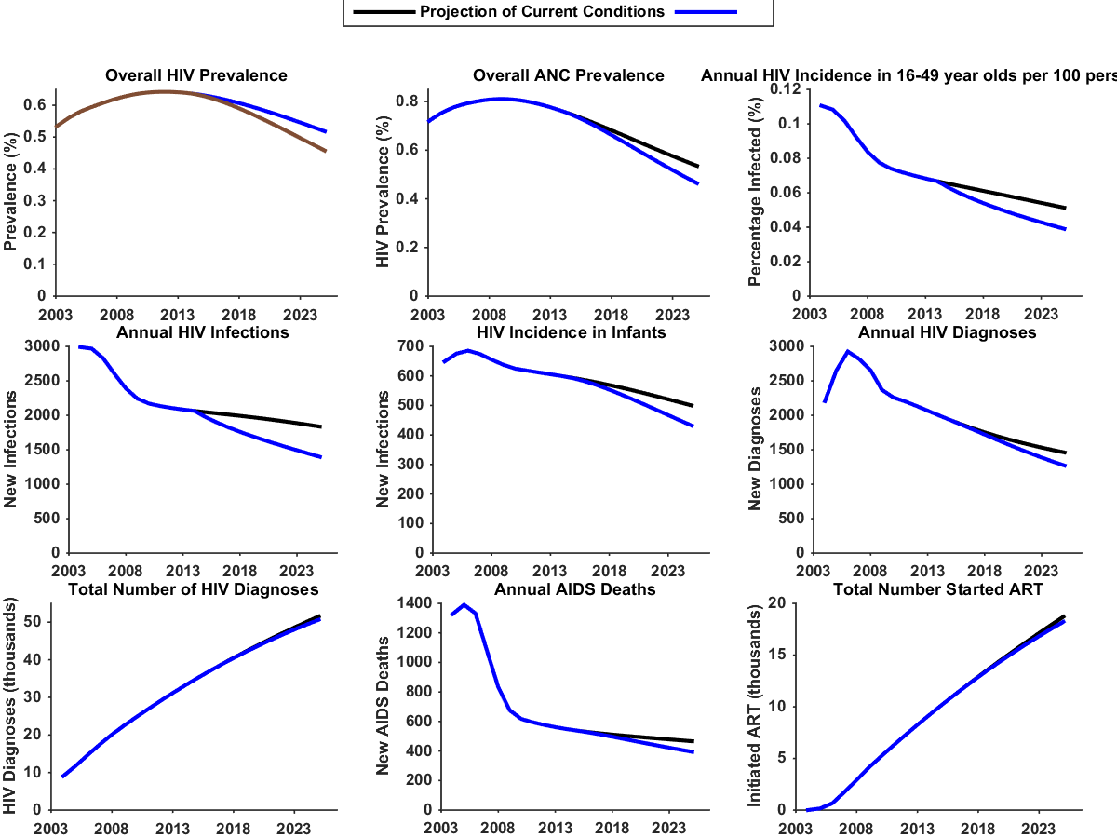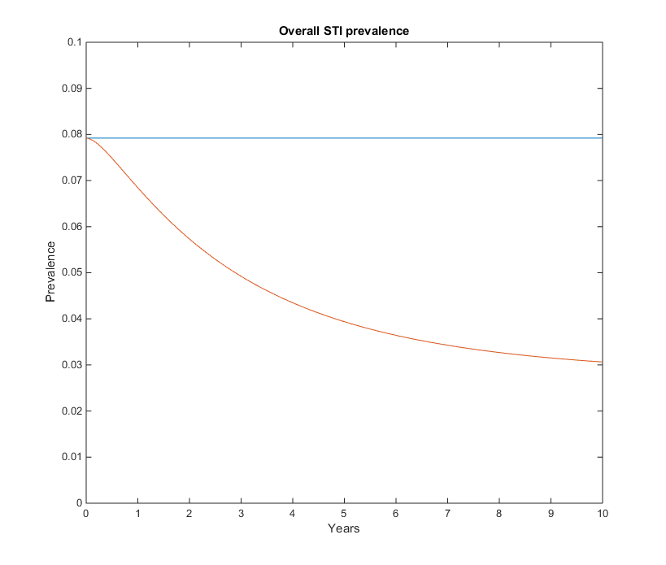 The plot on the left shows overall STIs falling dramatically with this intervention, compared to the non-equilibrium case. The plot on the right shows HIV incidence falling significantly.

Separating by sub-population and region we have the following STI prevalences:

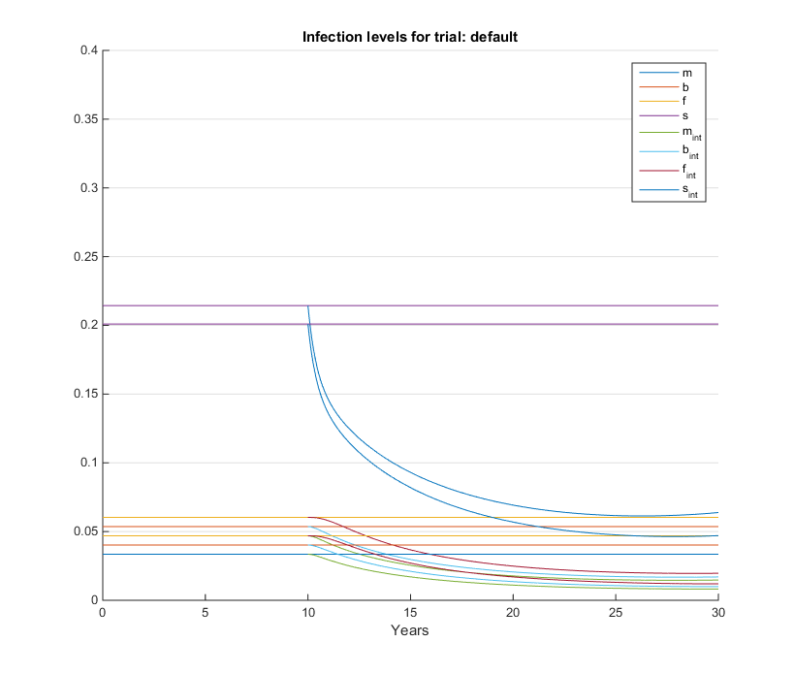

## Intervention variants

### Choice of sub-population

Providing PPT to general males and females at the same level as to FSW provides a large impact, but this is because there are far more general males and females than FSW. Providing the same number of total treatment doses but distributing these across the whole population results in almost no benefit (0.95% reduction in ulcerating STIs, 0.47% reduction in HIV). Providing PPT to MSMW at the same level as to FSW provides little additional benefit (2% further decrease in ulcerating STIs).

### Varying coverage and number of visits

I will add information here.

## Appendix

### Diagram showing the possible state changes in the model

Diagram 1: The possible states, and possible movements between states over a single period, in our model.

Susceptible

Infected

Resistant

Treatment and loss rate

Infection rate

PPT rate for susceptibles

PPT rate for infected

Move off treatment, and remain susceptible

Move off treatment and be infected immediately

### Description of the parameters in the table

|  |  |  |
| --- | --- | --- |
| Probability of state change (m1) | Description | Footnote |
| $$λ_{S}(t)\left(1-{Δ_{t}δ}_{S}\left(t\right)\right)$$ | Infection rate | m1 |
| $$γΔ_{t}\left(1-{Δ_{t}δ}_{S}\left(t\right)\right)$$ | Existing treatment and loss rate | m2 |
| $${Δ_{t}δ}_{S}\left(t\right)$$ | PPT rate for susceptible | m3 |
| $${Δ_{t}δ}_{S}\left(t\right)$$ | PPT rate for infected | m4 |
| $$λ_{S}(t)$$ | Move off PPT, then remain susceptible for one period | m5 |
| $$1-λ_{S}(t)$$ | Move off PPT, then become infected in the same period | m6 |
| m1: We include the $\left(1-{Δ_{t}δ}_{S}\left(t\right)\right)$ term because some people who were susceptible at time $t$ immediately receive PPT and enter the resistant group, then later perform sexual acts which would otherwise have infected them. Because these people are now resistant, they do not become infected.  m2: This accounts for all treatment other than PPT, as well as losses and births. Congenital syphilis has a very high mortality rate, and very few people infected at birth survive to enter the sexual population.  m3-m4: Because this only accounts for PPT, which is by definition presumptive, we assume that it is the same for susceptible and infected people. If a person suspects that they might be infected and seeks testing or treatment because of this, we assume that they would have done so anyway, and thus we include it in arrow 2.  m5-m6: We set the time step $Δ_{t}$ of our model equal to the duration of protection, so that the entire resistant population from one period becomes susceptible again at the start of the next period. These people have the same probabilities of remaining susceptible or being infected as the already susceptible people, except that we assume they will not receive PPT immediately after they lose their protection, for at least one period. | | |

### Results for all scenariosT:\Crock\SmallModel\Figures\Consequences of extending PPT to all populations.png

An intervention with 75% coverage of the entire population is much more effective than an intervention with 75% coverage of only FSW. However, FSW are only 1.56% of the PNG population, so the former intervention must reach approximately 64 times more people. An intervention which reaches the same number of people, spread evenly across the whole population, would reach only 1.17% of the population, and has a correspondingly much lower impact.

I will add something about providing treatment to the rest of the pop and not to FSWs, and something about holding FSW intervention constant and adding an appropriately small coverage of the rest of the pop.

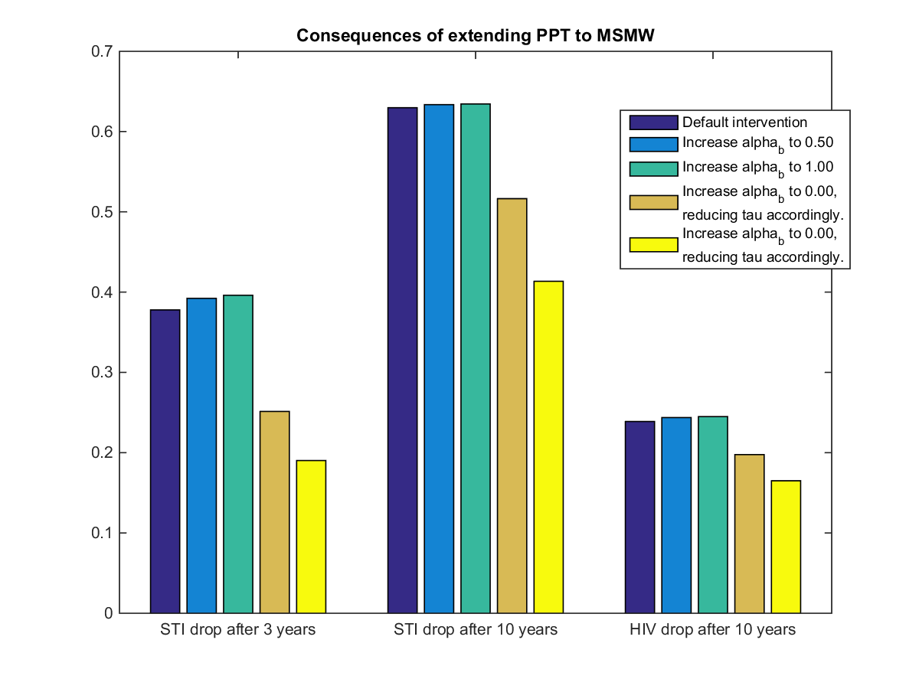 Expanding an intervention from FSW alone to FSW and MSMW has very little impact on outcomes, yet would still be expensive. 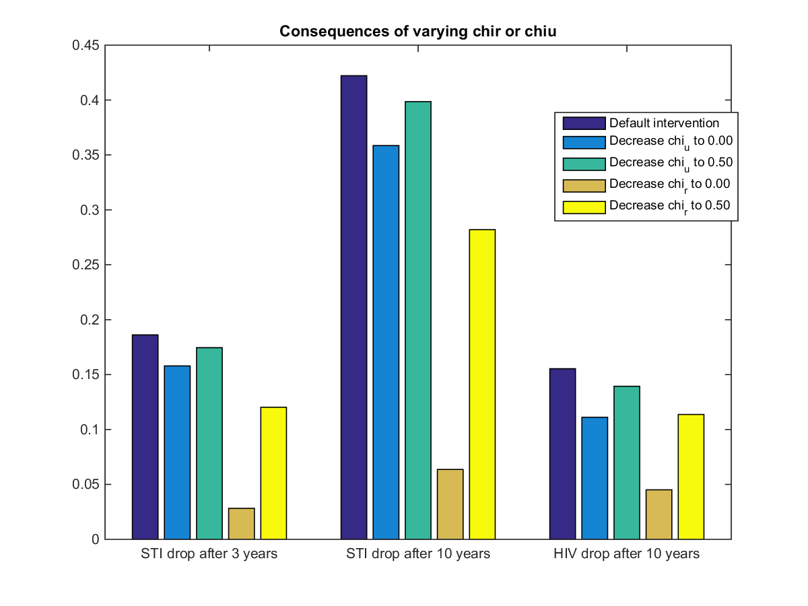I should probably add something where I run an intervention the size of the urban intervention for a rural population.

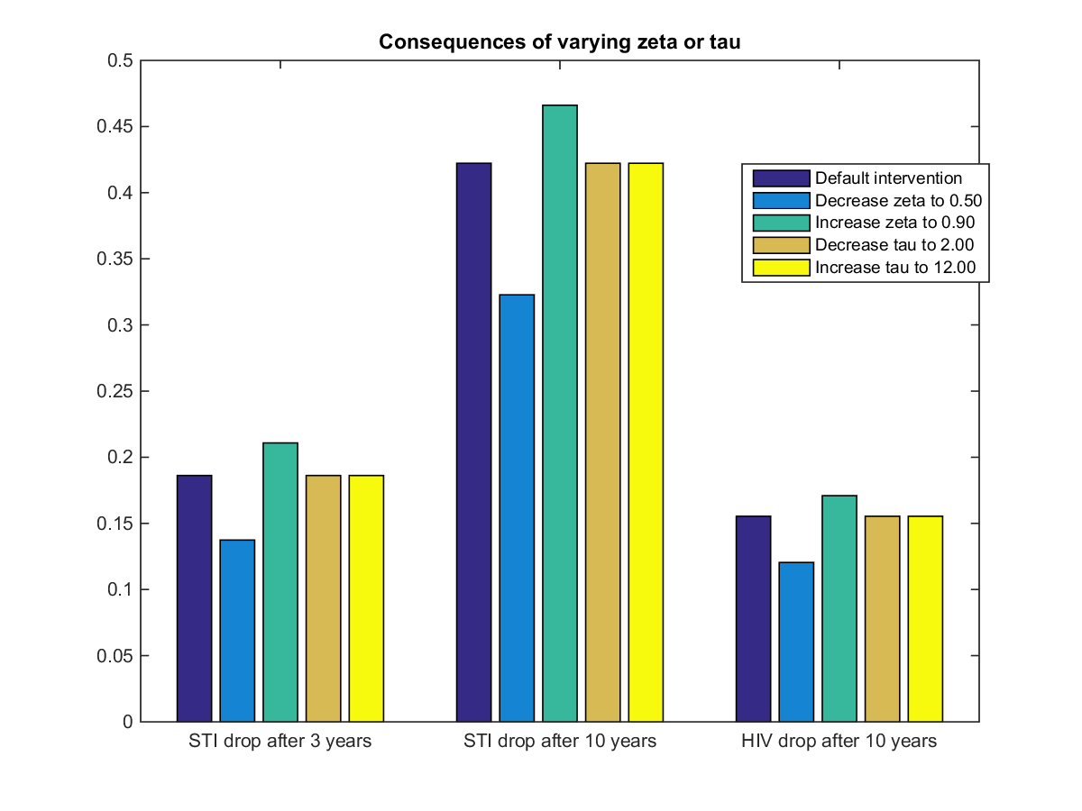

Tau is broken, I should fix it.

I need to fix up the choice of error bounds on my sensitivities.

### Sensitivity analysis

Not done: any of the sensitivity analysis for the higher or lower cofactors

### T:\Crock\SmallModel\Figures\Sensitivity to gamma and phi.png

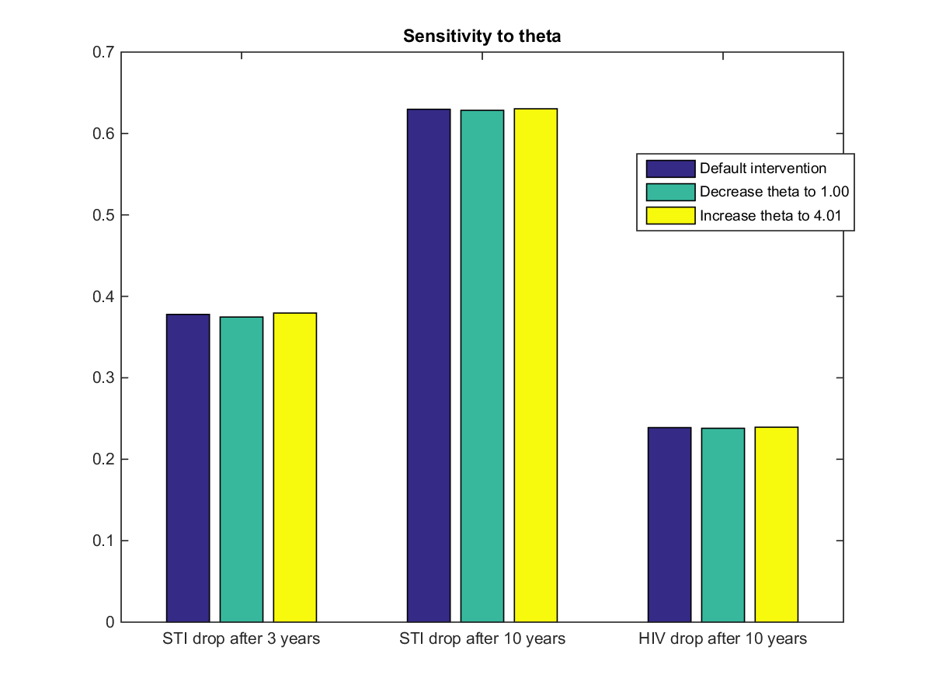

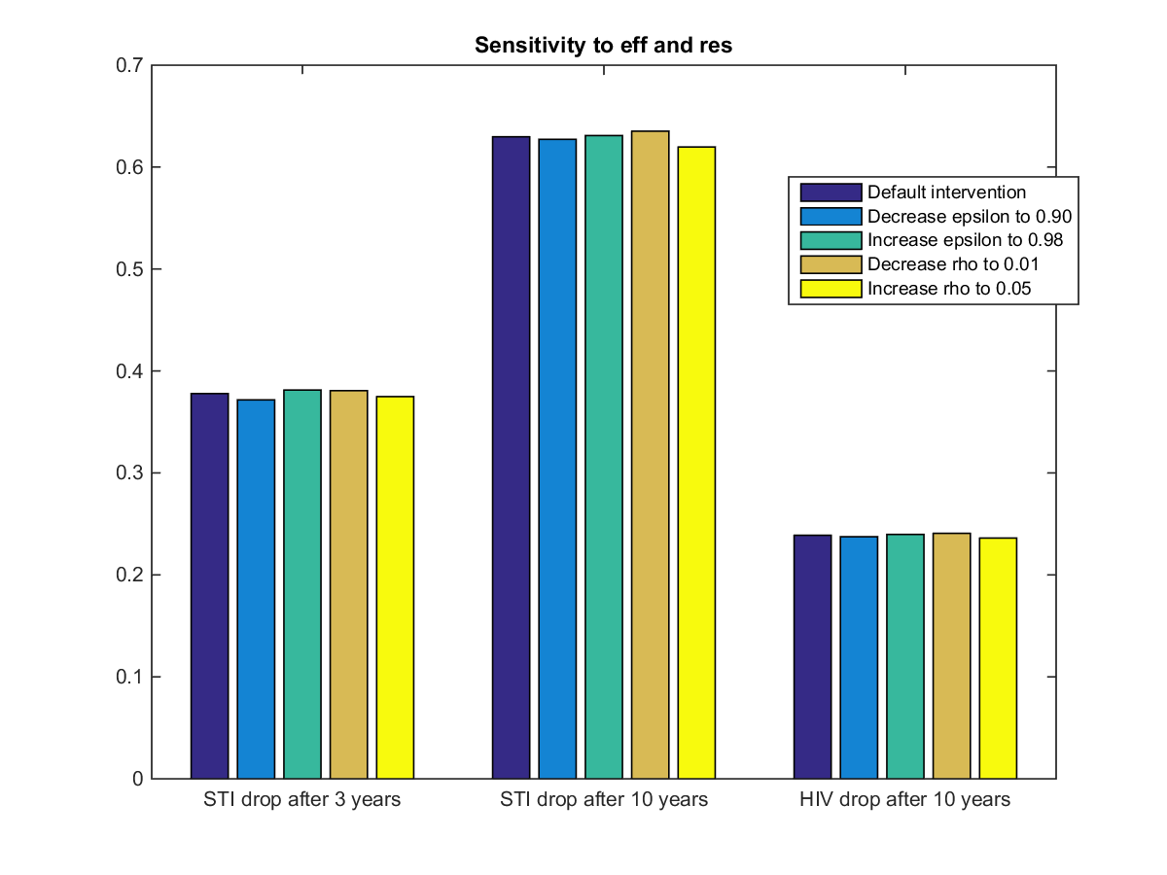

1. We supply values for a rural population one time step into a typical intervention